**Modeling and Solving Linear Programming Problems:  
Group 1**

**Jackie Mease  
Tyler Harris  
Christopher McManus  
Jonathan Sparger  
Kyle Anderson**

**Belk College of Business: School of Data Science, University of North Carolina at Charlotte**

**DSBA-6122: Decision Modeling and Analysis**

**Dr. Xiuli He**

**May 2, 2022**

**Introduction**

Our choice for the project is *Modeling and Solving Linear Programming Problems*, for which we demonstrated using Case 3.1: Putting the Link in the Supply Chain.

This case required us to create and solve a linear programming problem in which a golf club producer is making and selling golf clubs using given revenue, cost and constraints, in order to maximize profit margins.

We followed the below approach for this case:

1. Identify and define decision variables
2. Define objective function
3. Identify constraints and formulate full LP model
4. Solve for optimal solution
5. Determine if/how to improve solution and what resources would be required
6. Re-solve the LP model without the minimum 90% demand constraint and identify new optimal solution
7. Re-solve the LP model with an additional $10,000 cost but only had to meet 80% of demand; identify pros and cons of this approach

**Optimal Production & Shipping Plan**

Obj =Determine an optimal production and shipping plan for the coming month for selling golf clubs using given revenue, cost and constraints, in order to maximize profit margins.

Let Xhij = number of golf clubs to produce/sell from product line *h* (m = Mens, w = Womens, j = Junior) shipped from location *i* (D = Daytona, M = Memphis, T = Tempe) to location *j* (S = Sacramento, d = Denver, P = Pittsburgh)

MAX = 174XmDS + 197XmDd + 189XmDP + 215XmTS + 182XmTd + 169XmTP + 146XwDS + 168XwDd + 161XwDP + 162XwMS + 173XwMd + 182XwMP + 186XwTS + 153XwTd + 141XwTP + 134XjMS + 144XjMd + 153XjMP + 157XjTS + 125XjTd + 113XjTP

ST

2.9XmDS + 2.9XmDd + 2.9XmDP + 2.7XwDS + 2.7XwDd + 2.7XwDP < 4,500 Titanium - Daytona

2.7XwMS + 2.7XwMd + 2.7XwMP + 2.5XjMS + 2.5XjMd + 2.5XjMP < 8,500 Titanium - Memphis

2.9XmTS + 2.9XmTd + 2.9XmTP + 2.7XwTS + 2.7XwTd + 2.7XwTP + 2.5XjTS + 2.5XjTd + 2.5XjTP < 14,500 Titanium - Tempe  
4.5XmDS + 4.5XmDd + 4.5XmDP + 4XwDS + 4XwDd + 4XwDP < 6,000 Aluminum - Daytona

4XwMS + 4XwMd + 4XwMP + 5XjMS + 5XjMd + 5XjMP < 12,000 Aluminum - Memphis  
4.5XmTS + 4.5XmTd + 4.5XmTP + 4XwTS + 4XwTd + 4XwTP + 5XjTS + 5XjTd + 5XjTP < 19,000

Aluminum - Tempe

5.4XmDS + 5.4XmDd + 5.4XmDP + 5XwDS + 5XwDd + 5XwDP < 9,500 Rock Maple- Daytona

5XwMS + 5XwMd + 5XwMP + 4.8XjMS + 4.8XjMd + 4.8XjMP < 16,000 Rock Maple-Memphis

5.4XmTS + 5.4XmTd + 5.4XmTP + 5XwTS + 5XwTd + 5XwTP + 4.8XjTS + 4.8XjTd + 4.8XjTP < 18,000 Rock Maple - Tempe

XmDS + XmTS > 630 Men's Orders (Sacramento Min)

XmDd + XmTd > 495 Men's Orders (Denver Min)

XmDP + XmTP > 810 Men's Orders (Pittsburgh Min)

XwDS + XwMS + XwTS > 810Women's Orders (Sacramento Min)

XwDd + XwMd + XwTd > 900 Women's Orders (Denver Min)

XwDP + XwMP + XwTP > 1,080 Women's Orders (Pittsburgh Min)

XjMS + XjTS > 810 Junior's Orders (Sacramento Min)

XjMd + XjTd > 1,350 Junior's Orders (Denver Min)

XjMP + XjTP > 990 Junior's Orders (Pittsburgh Min)

XmDS + XmTS < 700Men's Orders (Sacramento Max)

XmDd + XmTd  < 550 Men's Orders (Denver Max)

XmDP + XmTP < 900 Men's Orders (Pittsburgh Max)

XwDS + XwMS + XwTS < 900Women's Orders (Sacramento Max)

XwDd + XwMd + XwTd < 1,000 Women's Orders (Denver Max)

XwDP + XwMP + XwTP < 1,200 Women's Orders (Pittsburgh Max)

XjMS + XjTS < 900 Junior's Orders (Sacramento Max)

XjMd + XjTd < 1,500 Junior's Orders (Denver Max)

XjMP + XjTP < 1,100 Junior's Orders (Pittsburgh Max)

Xhij > 0 for all *h*, *i* and *j*

When input into the Excel model, the optimal solution is to produce and ship 495 Men’s (Daytona to Denver), 810 Men’s (Daytona to Pittsburgh), 630 Men’s (Tempe to Sacramento), 31.875 Women’s (Daytona to Denver), 459.31034 Women’s (Memphis to Sacramento), 868.125 Women’s (Memphis to Denver), 1080 Women’s (Memphis to Pittsburgh), 350.68966 Women’s (Tempe to Sacramento), 474.05172 Junior’s (Memphis to Pittsburgh), 810 Junior’s (Tempe to Sacramento), 1350 Junior’s (Tempe to Denver), and 515.94828 Junior’s (Tempe to Pittsburgh). This would result in a Profit Margin of **$1,304,544**.

*Table 1: Optimal Solution 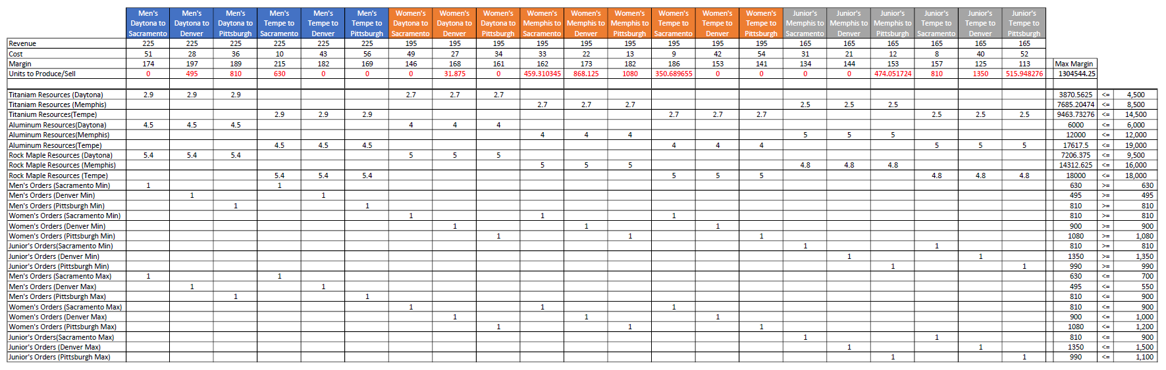*

**Improved Solution**

If Rick wants to improve the previously discussed solution, additional resources will be needed to reach the maximum production capacity, therefore, increasing the overall profit. Currently, each order of golf clubs is being fulfilled at the 90% minimum due to the lack of materials which include aluminum and rock maple. To reach maximum production, Rick would need to add 850 pounds of aluminum to Daytona, 2,241 pounds of aluminum to Memphis, and 2,139 pounds of rock maple to Tempe. This would mean that the new total amount of material would be 6,850 pounds of aluminum in Daytona, 14,241 pounds of aluminum in Memphis, and 20,139 pounds of rock maple in Tempe. The reason these three locations were selected to receive additional materials is due to the previous solution having these locations with their respective material binding, therefore, reaching the max amount of material that was available for production. With these locations reaching their threshold on the material at hand, this stopped further production of the golf clubs, making these vital to fully complete each order. Each of these three locations has been given additional resources to the exact amount needed to fulfill each order of golf clubs at full. This increases Rick’s profit by $178,970, bringing overall profits to a grand total of $1,483,515. The improved solution can be previewed in the table below.

*Table 2: Improved Optimal Solution*

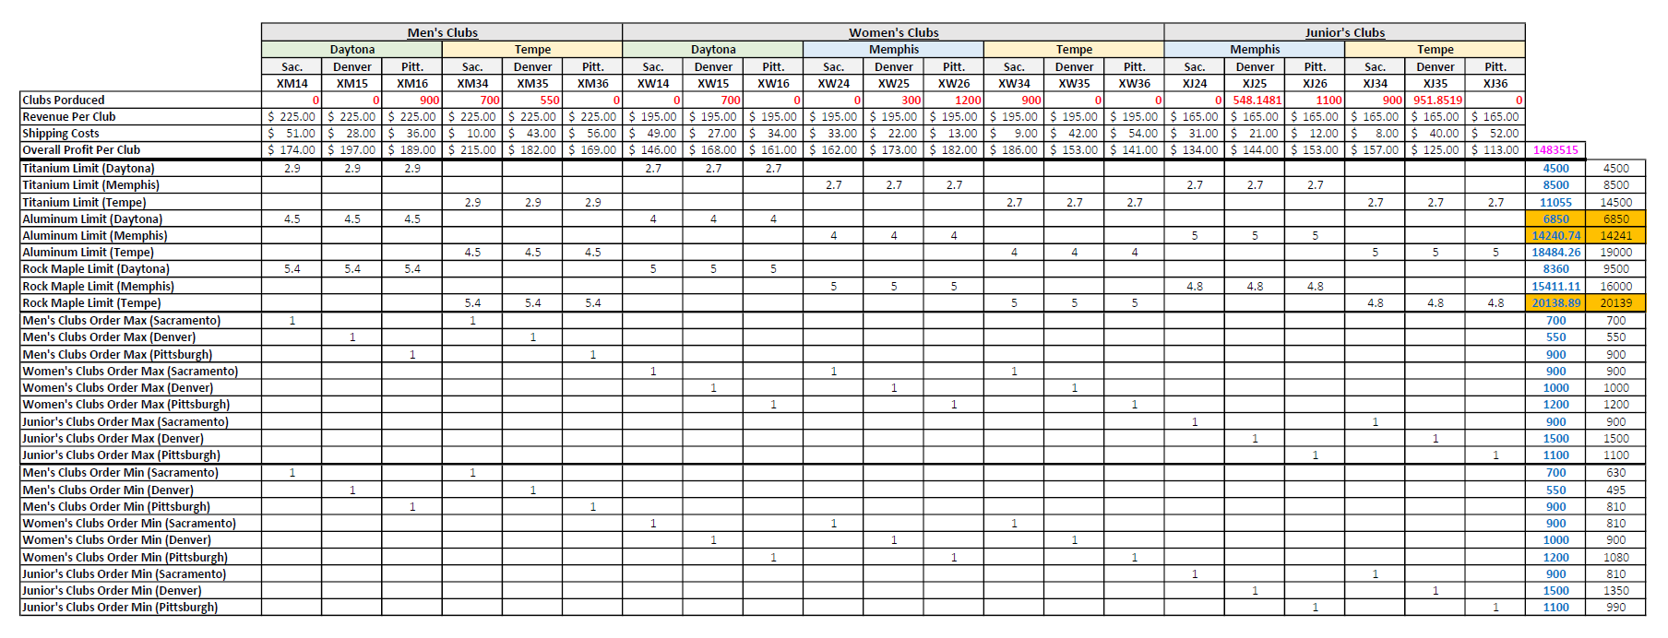

**No Minimum Fill-Rate**

If a minimum 90% fill rate was not required for each distributor order, TGL’s profits would be $1,349,439. With no minimum fill rate, all distributor orders, except for Denver Junior’s and Pittsburgh Junior’s, would become binding constraints. The number of club sets supplied – for these binding constraints – is equal to the number ordered. With no minimum fill rate, TGL’s optimal profit would be $44,895 more than the original optimal solution, which requires a minimum 90% fill rate.

*Table 3: No Minimum Fill-Rate*

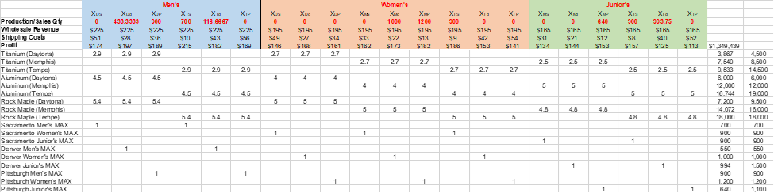

**Penalty Option**

If we explore the option to not produce at least 90% of the orders but only 80-89% and pay a $10,000 penalty per distributor order instead, we will experience a lower profit margin at $1,223,826.26. In our optimal model where we provided at least 90% of the order, we were producing exactly at that amount. In the new model producing less than 90% but at least 80%, the optimal model produces/sells 89% of the orders. Therefore, we are making slightly less profit margin and then additionally losing the $90,000 penalty.

*Table 4: Penalty Option*

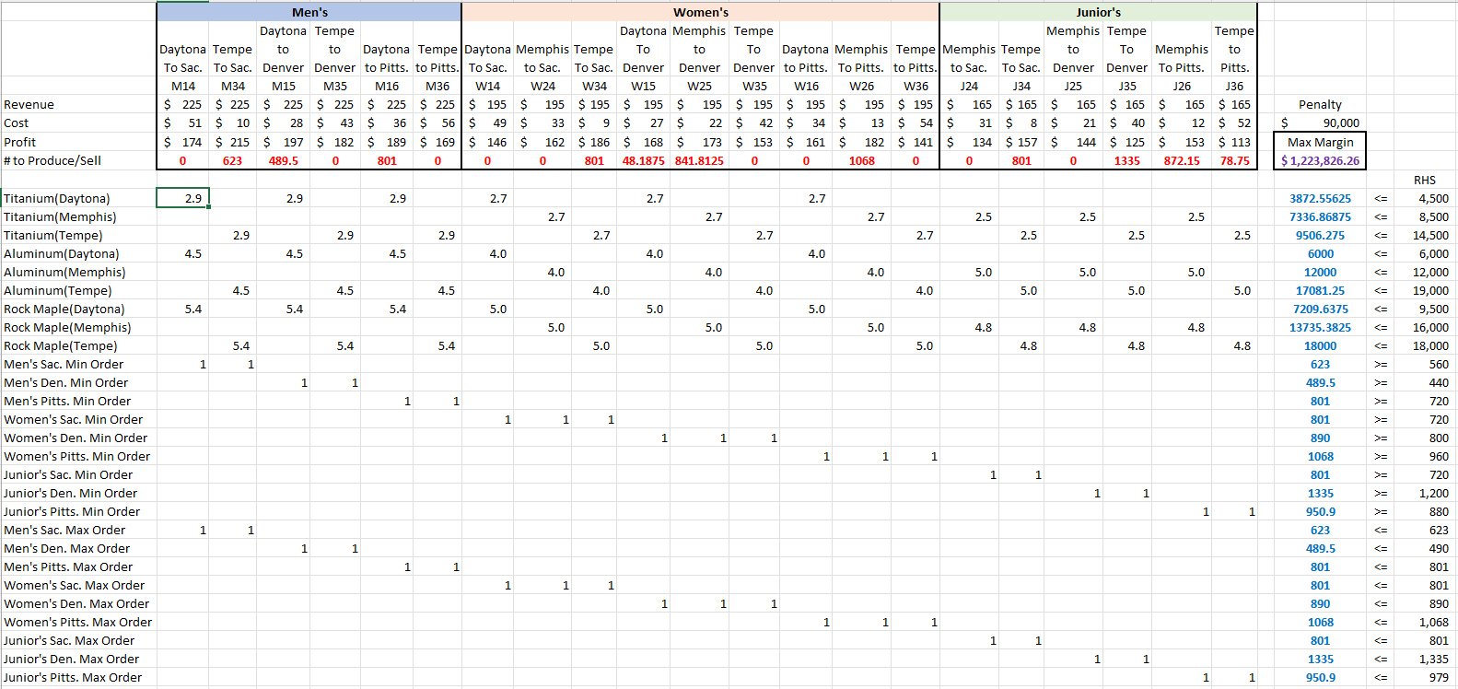

**Penalty Option Alternative Solution**

If the penalty option is explored again with the company supplying at least 80% of the distributor's orders instead of 90% without including an 89% maximum supply cutoff. And once more, we pay $10,000 for each order where at least 90% of each distributor's order is not supplied, the profit margin increases to $1,289,986.25. With either option, the profit margin is lower than the original agreement's profit margin of $1,304,544. However, the alternative option has a higher profit margin than with the inclusion of the 89% maximum cutoff. Instead of paying a $90,000 penalty, the penalty is only $40,000 from supplying the Pittsburgh’s men's distributor with at least 80% of their order, as well as supplying all of the junior distributors with at least 80% of their orders.

*Table 5: Penalty Option (Alternative Solution)*

